**SOP – How to complete eLearning**

Please follow the guide below once you have signed into ESR.

1. **Click on Go to MyESR Portal**

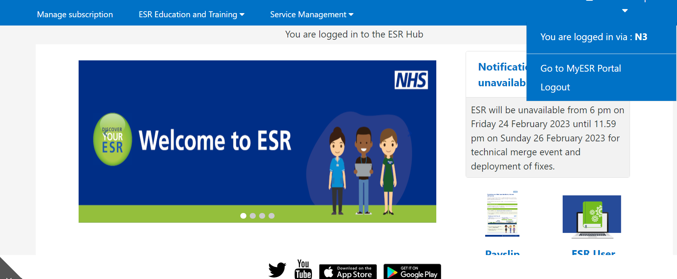

1. **Find My Compliance portlet and click on the blue arrow, then click into the small circle, next to the competence you wish to complete.**

1. **If the Play button is not greyed out, you can click it to launch e-learning.**

1. **Please ensure that you click the Blue House icon once you have finished the module. This is located in the top right of the module.**

**Please see below guidance if the Play button is greyed out.**

1. **If the Play button is greyed out, then you will need to subscribe onto the Certification by clicking on the magnifying glass.**

1. **Click on the Details box under Certifications**
2. **Click on Subscribe**
3. A picture containing text

   Description automatically generated**Click on Finish**
4. **Click on Enrol.**

1. **You have now successfully enrolled onto the e-learning module. Click onto the Portal button to access the ESR Dashboard.**
2. **The Play button should now be highlighted, click on this to play the course.**

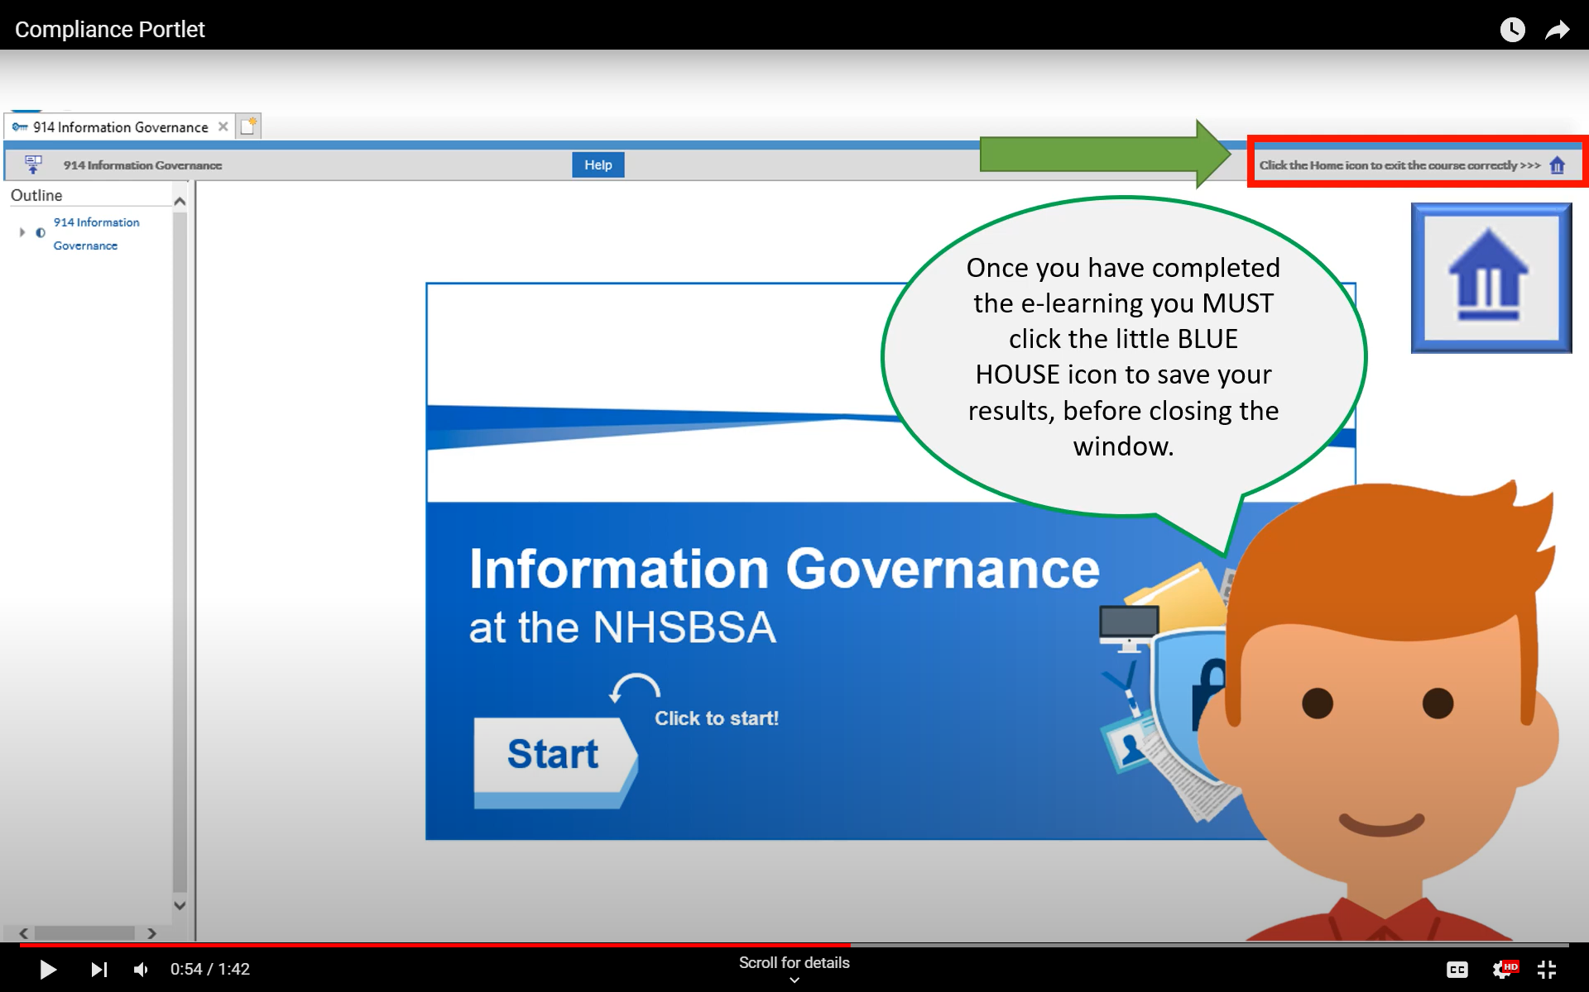**Please ensure that you click the Blue House icon once you have finished the module. This is located in the top right of the module.**