**SOP – How to renew a course certification.**

Please follow the guide below once you have signed into ESR.

1. Click on Go to MyESR Portal.

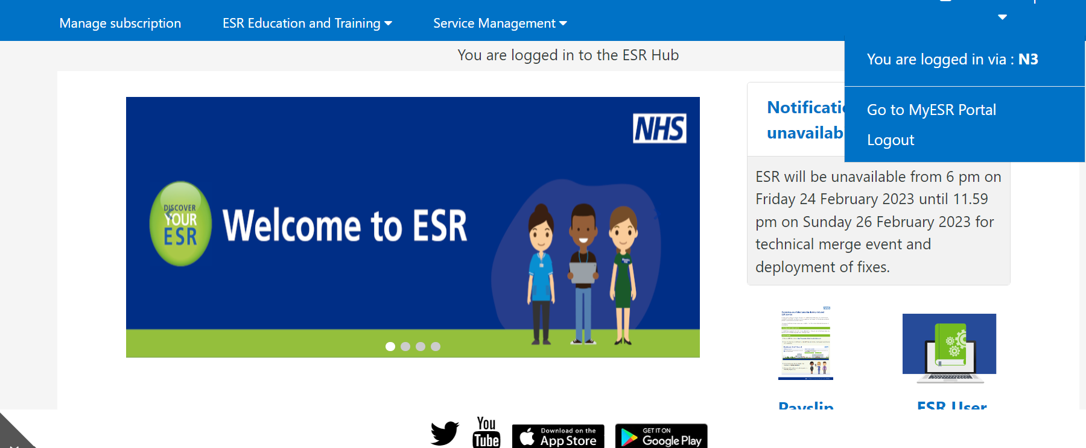

1. Using the list on the left-hand side of the page, click the ‘My Learning’ button.

1. Locate the below table and using the cursor, click on the certification.
2. You will now see the below table. Find the training you need to renew your certification for.

1. Click the yellow briefcase button as seen below to unsubscribe from the course.

1. You will then see the below. Click yes.



1. Then go back to MyESR Portal.

1. Follow the steps on the How to Play eLearning Module Guide.